LEETCODE
Total Distance Traveled - LeetCode
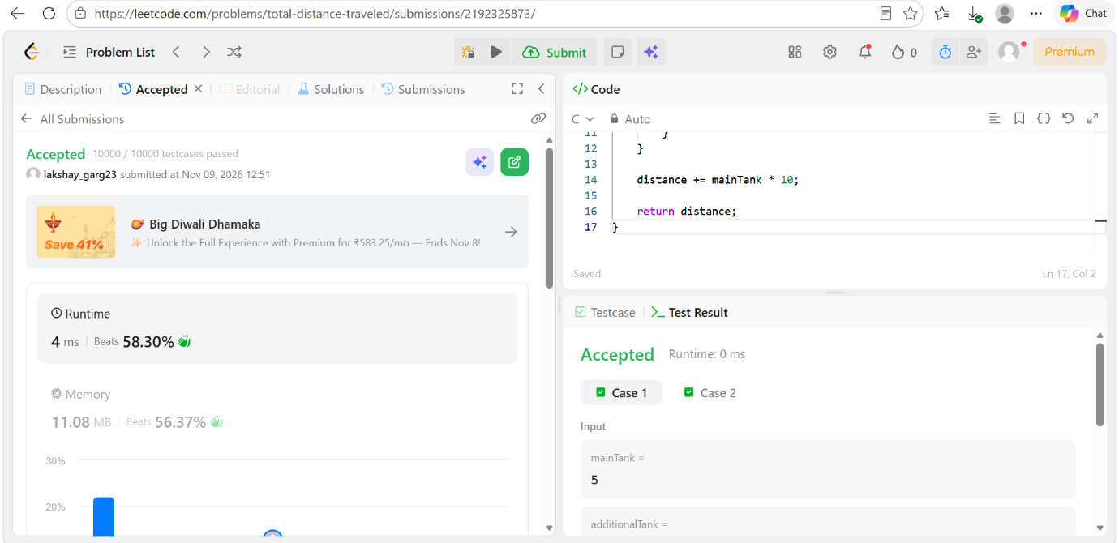

CODE
int distanceTraveled(int mainTank, int additionalTank) {
int distance = 0;

while (mainTank >= 5) {
distance += 50;
mainTank -= 5;

if (additionalTank > 0) {
mainTank++;
additionalTank--;
}
}

distance += mainTank * 10;
return distance;
}

